

**Supporting Tools**





# 4. Supporting Tools

**Service Now (Snow)**

Ticketing software allows organizations to resolve their internal IT issues by streamlining the resolution process. The elements they handle, called tickets, provide context about the issues, including details, categories, and any relevant tags.

**What is a ticket?**

Within an employee IT ticketing system, a ticket is a special document or record that represents an incident, alert, request, or event that requires action from the IT department. It often contains additional contextual details and may also include relevant contact information of the individual who created the ticket.

Tickets are usually employee-generated, but automated tickets may also be created when specific incidents occur and are flagged. Once a ticket is created, it is assigned to an IT agent to be resolved. Effective ticketing systems allow tickets to be submitted via a variety of methods. These include submissions through virtual agents, phone, email, service portals, live agents, walk-up experience, etc.

There are a number of work types used for IT Service Management. When assigned to the correct type, work gets the handling appropriate to it.

The types are:

* Service request
* Incident
* Change
* 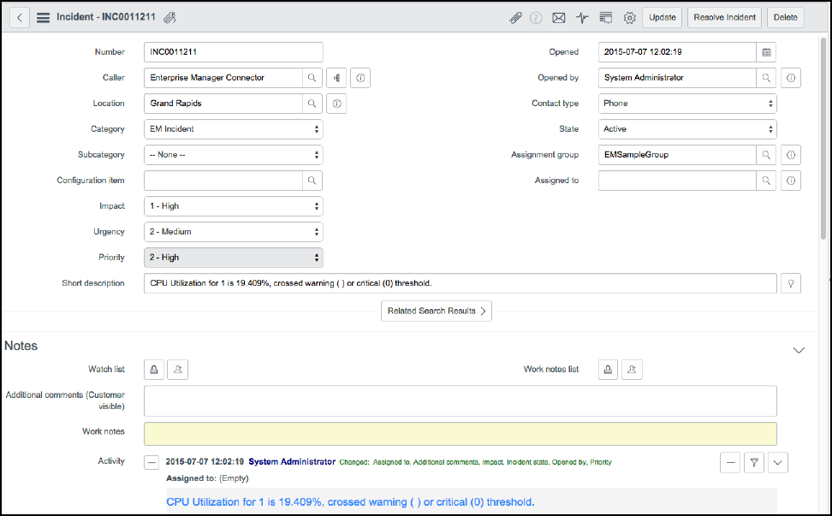

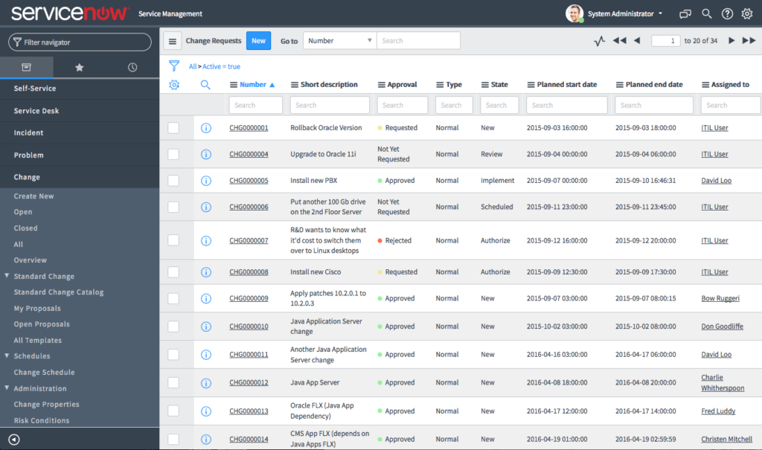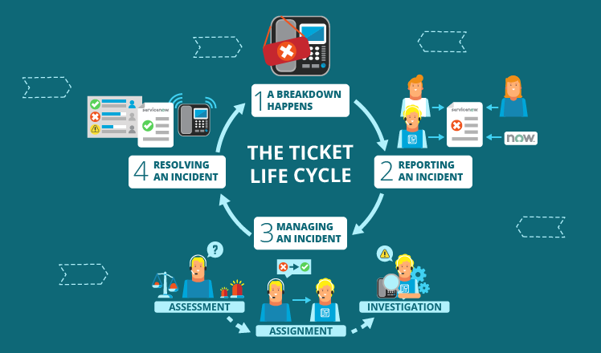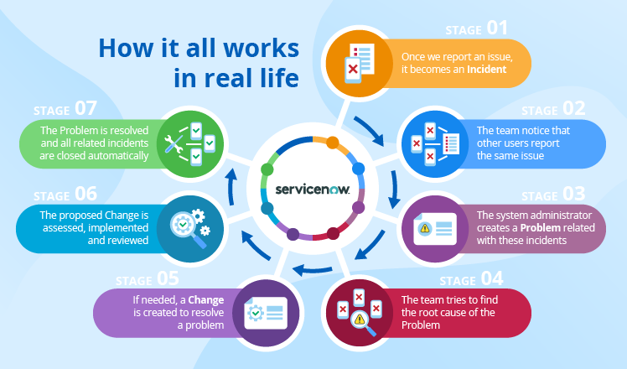

**Service request**

A service request is a request from a user for information, advice, or access to an IT service, such as:

* Associate asks for a access of particular server.
* A telecom coordinator requests a new desk phone on behalf of someone they support.

**Incident**

Let’s suppose you work in an organization, and you are using outlook for connectivity, then you face issue while opening the outlook you are not able to connect to the outlook.

Then you will raise this concern to the related team (who is responsible for outlook).

**Problem**

The corresponding team will look into it, and try to fix it. If they don’t find any root cause for the incident and if they get multiple incidents for the same underlying cause then the incident will be considered as a problem. They will give you some workaround until the root cause is determined.

* If multiple users are facing the same issue with the outlook.

**Change**

If after investigation, the technical team found that the outlook server requires patching to resolve this issue. the respective team will raise the change request to apply OS patch on the server.

A change is an addition, modification, or removal of anything that could affect Production. This may include IT services, configuration items, processes, documentation, and other related elements.

**Outlook:**

Outlook allows you to send and receive email messages, manage your calendar, store names and numbers of your contacts, and track your tasks. However, even if you use Outlook every day, you might not know some of the cool things it can do to help you be more productive.

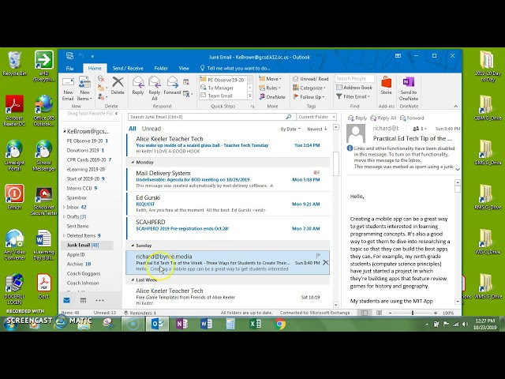

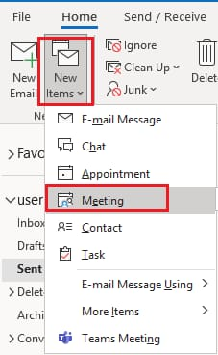

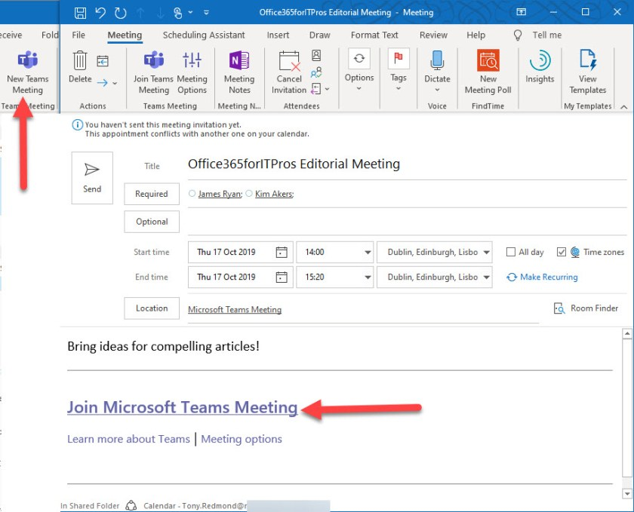

Teams:

